**Pre-requisites**

1. Open SalesTax.sln solution in Visual Studio (*Developed in Visual Studio 2017*)
2. Set ‘BuildReceipt.aspx’ as start page
3. Play solution within Visual Studio



**How to use**

1. Enter product information using the form to the left of the page
   1. Select the product type from the drop down
   2. If the product is imported, tick the checkbox

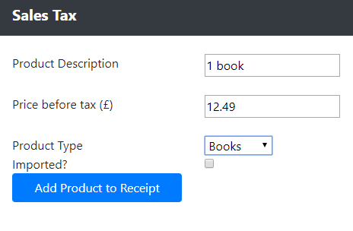

1. Clicking the ‘Add Product to Receipt’ button will add this product to the receipt to the right of the page.

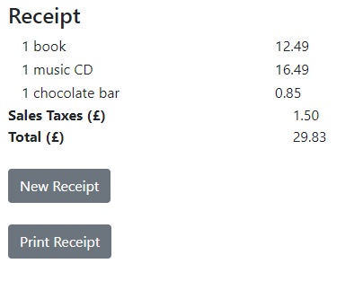

1. Clicking the ‘New Receipt’ button will clear down the current receipt that is being built.
2. Clicking the ‘Print Receipt’ button will take you to a print friendly HTML page so the receipt can be printed.

